**Examining the Impact of Independent Commissioners, Audit Committees, and Board of Directors on Financial Performance: A Contemporary Analysis**

Priska1, Nabila Aurelia2

[priska@student.ubl.ac.id](mailto:priska@student.ubl.ac.id)

[nabila.aurelia@student.ubl.ac.id](mailto:nabila.aurelia@student.ubl.ac.id)

12Universitas Bandar Lampung

**Abstract**

This study investigates the impact of three independent variables - independent commissioners, audit committees, and board of directors - on financial performance as the dependent variable. Employing a purposive sampling method, 16 companies were selected based on predetermined characteristics from a population of food and beverage companies listed on the Indonesian Stock Exchange (BEI) between 2017 and 2019, totaling 48 companies. Utilizing multiple linear regression analysis, the research undertook descriptive statistics, impression statistics, and classical assumption tests, followed by hypothesis testing to empirically assess the relationships. The findings shed light on the influence of these governance mechanisms on financial performance, offering insights into their effectiveness in shaping organizational outcomes. This contemporary analysis contributes to the literature by providing empirical evidence regarding the roles of independent commissioners, audit committees, and board of directors in enhancing or detracting from company performance, thereby informing corporate governance practices and strategies for maximizing financial outcomes.

Keywords: Independent Commissioner (KI), Audit Committee (KA), Board of Directors (DD), Company Performance (ROA)

**Introduction**  
Financial performance is a vital measure of a company's overall well-being, demonstrating its effectiveness in operations and its financial stability during a certain period. Financial reports include valuable insights and act as crucial instruments for conveying the company's financial position to stakeholders, including creditors, owners, investors, and management (Frias-Aceituno et al., 2014; Ives, 2015; Shahwan, 2008).Through the examination of financial reports, organisations can evaluate past and present financial conditions and make predictions about future circumstances. This enables them to make well-informed decisions that contribute to increasing profitability. The Return on Assets (ROA) ratio is a crucial metric for evaluating financial performance. It measures the company's profitability in relation to its asset base (Bhujel, 2020; Kopecká, 2018; Thomas, 2003).

The main goal of any firm is to optimise profits in order to meet obligations to shareholders or investors and improve total shareholder value. To accomplish this goal, it is essential to have efficient corporate governance, which is commonly established through the implementation of a Good Corporate Governance (GCG) system. Effendi (2016) highlights that the fundamental elements of corporate governance encompass the General Meeting of Shareholders (GMS), board of directors, and commissioners (Aebi et al., 2012; Ika et al., 2021; Walls et al., 2012). The board of directors, consisting of corporate owners or chosen individuals with expertise, takes on the job of overseeing and directing the company's activities. Efficient corporate governance requires supervisory measures to restrict the board of directors, guaranteeing their compliance with the company's overall goals (Ika et al., 2021; Uzma, 2018; Walls et al., 2012).

Independent commissioners serve as crucial entities within the corporation, advocating for the rights and interests of minority owners and other stakeholders. Independence, in this sense, refers to the state of being free from any associations or obligations with the board of directors or other commissioners that could potentially undermine their capacity to impartially oversee management. The audit committee, formed by the board of commissioners, aims to enhance oversight capacities and strengthen governance frameworks inside the corporation, specifically in upholding GCG standards (Ika et al., 2021; Walls et al., 2012).

Amidst this situation, a worrisome pattern has arisen, as three out of sixteen food and beverage companies have witnessed a decrease in their Return on Assets (ROA) from 2018 to 2019. This phenomena highlights the significance of examining if factors such as autonomous commissioners, audit committees, and the board of directors have an impact on financial performance (Abbasi et al., 2020; Ika et al., 2021; Sun et al., 2011). Hence, the objective of this study is to investigate the correlation between these governance elements and financial performance, with the intention of offering valuable perspectives to enhance corporate governance procedures and eventually enhance financial results for food and beverage companies.

**Literature Review**

Agency theory provides useful insights into the dynamics that exist between principals and agents within organisational systems. Principals, usually represented by shareholders, assign authority to agents, commonly the board of directors, to oversee the company's operations (Choi et al., 2021; Ejoh et al., 2019; Walls et al., 2012). The primary aim of agency theory is to tackle the inherent agency problems that arise from conflicting interests or objectives between these parties. These disparities might lead to a deficiency in complete confidence from principals towards agents, thus requiring the implementation of supervisory measures such as independent commissioners and audit committees (Choi et al., 2021; Shailer, 2018; Singh & Davidson III, 2003). The purpose of these oversight organisations is to supervise firm management, guaranteeing compliance with company policies and reducing agency expenses. Agency costs refer to the financial burdens associated with overseeing and regulating the behaviour of agents, in order to ensure that their activities are in line with the objectives of the principal or the overall goals of the organisation (Abbot et al., 2016; Al-Hadrami et al., 2020; Aulakh & Gencturk, 2000; Coles et al., 2001).

Evaluating a company's financial performance is crucial for determining its capacity to apply efficient corporate governance strategies and produce profits. Financial performance analysis provides an assessment of the company's financial well-being based on strong governance principles. Independent commissioners serve as a crucial internal control mechanism responsible for supervising the policies of top management (Abbott & Parker, 2000; Kueppers & Sullivan, 2010; Steinberg & Faulk, 1991). The top management, typically represented by the board of directors, consists of either the company's controlling shareholders or capable individuals appointed by them to guide the company's direction. To address the difficulties that come with the commissioner's responsibility for overseeing operational activities, the establishment of an audit committee helps to strengthen their ability to monitor and fulfil their supervisory obligations (Brennan & Solomon, 2008; Hooghiemstra & Van Manen, 2004).

The interaction among autonomous commissioners, audit committees, and the board of directors highlights the complex dynamics of corporate governance instruments. Independent commissioners act as custodians of shareholder interests, responsible for assuring managerial responsibility and compliance with company goals (Klein, 2002; Turley & Zaman, 2004; Zhang et al., 2007). Their position is strengthened by the combined efforts of audit committees, which offer extra levels of supervision, particularly in examining financial reporting methods and internal control systems. The board of directors, being the highest governing authority, has the ultimate duty for guiding the company's strategic course while ensuring transparency, accountability, and integrity (Baker & Owsen, 2002; Baxter, 2010; Deli & Gillan, 2000).

The symbiotic link between these governance components highlights their combined role in promoting corporate transparency, reducing agency risks, and improving overall financial performance. Therefore, it is crucial to thoroughly examine how these factors are connected in order to understand their influence on organisational results and to develop effective approaches for strengthening corporate governance systems in order to achieve long-term value generation (Bebchuk & Weisbach, 2010; Bushman et al., 2004; Walls et al., 2012).

**Methodology**

The current study utilises a quantitative methodology, employing panel data analysis to examine the associations identified in the literature review. Panel data is a comprehensive dataset that includes information collected over multiple time periods for a group of cross-sectional units. It provides a strong framework for studying the interactions between independent commissioners, audit committees, board of directors, and financial performance in food and beverage companies (Deli & Gillan, 2000; Krishnamoorthy et al., 2002).

The data collection for this study is based on secondary sources, namely annual reports obtained from a population consisting of 26 food and beverage firms listed on the Indonesia Stock Exchange (IDX) over the period from 2017 to 2019. A purposive sampling strategy is used to pick a sample of companies that is representative and includes organisations with various features and operating situations for analysis (Choi et al., 2021; Saha et al., 2018).

The statistical software package SPSS is used to ease the analysis and interpretation of data. The research process consists of several crucial steps, which include descriptive statistics, tests of classical assumptions, and hypothesis testing. Descriptive statistics are used to analyse and describe the sample data, giving us information about the average, spread, and distribution of important variables being studied (Choi et al., 2021; Karim & Purwanto, 2020; Saha et al., 2018).

Impression statistics or classical assumption tests are performed to verify the appropriateness of the regression model used in the research. These tests are conducted to confirm that there are no biases in the regression equation. They ensure that the estimated parameters are linear, unbiased, and have minimal variation, which improves the reliability and strength of the conclusions (Brown & Caylor, 2009; Reddy et al., 2010; Renders et al., 2010).

The core of the analytical framework revolves around hypothesis testing, which includes multiple linear regression modelling, evaluation of the coefficient of determination (R^2), and the t-test. The researcher aims to determine the impact of independent commissioners, audit committees, and board of directors on the financial performance of the selected food and beverage companies using multiple linear regression analysis (Deli & Gillan, 2000; Lin & Hwang, 2010; Mao & Gu, 2008). The coefficient of determination test (R2) quantifies the amount of variation in financial performance that can be attributed to the independent variables. It gives vital information about the strength of the relationships being examined. Afterwards, the t-test is used to evaluate the statistical significance of various regression coefficients, allowing the researcher to determine the size and direction of the influence of each governance component on financial performance (Choi et al., 2021; Chu et al., 2019; Deli & Gillan, 2000; Lin & Hwang, 2010; Liu et al., 2018).

This research seeks to use a rigorous and systematic approach to examine how corporate governance mechanisms affect financial performance in the food and beverage industry. The findings will contribute to the existing knowledge and help inform strategic decision-making.

**Results**

The main aim of this study is to analyse the influence of independent commissioners, audit committees, and boards of directors on the financial performance of food and beverage corporations. In order to accomplish this purpose, a purposive sampling technique was utilised to choose a sample of organisations that had specific features that are important to the research goals. A total of 16 companies were selected for analysis using this sampling strategy.

The research sample consists of food and beverage companies listed on the Indonesian Stock Exchange (IDX) over the period from 2017 to 2019. The selected time period was intended to get a thorough and complete overview of corporate governance policies and financial performance trends spanning three years. The dataset used in this study consists of financial data obtained from the annual reports of 48 food and beverage companies listed on the IDX during the required timeframe.

This research aims to provide detailed insights into the complex connections between corporate governance processes and financial performance outcomes by utilising data from a wide range of companies in the food and beverage industry. The study aims to use thorough analysis and interpretation of the gathered data to examine the impact of independent commissioners, audit committees, and boards of directors on the financial performance of food and beverage companies in the Indonesian market.

The careful selection of the sample and thorough coverage of the population highlight the strength and dependability of the findings produced by this research endeavour. This study seeks to clarify the relationship between governance structures and financial performance metrics. Its goal is to provide valuable insights for strategic decision-making and contribute to the ongoing discussion on corporate governance practices and their impact on organisational success in the food and beverage industry.

# Table 1

# Research Sample Results

|  |  |  |
| --- | --- | --- |
| No. | Information | Total |
| 1 | Food and beverage companies listed on the Indonesia Stock Exchange for the 2017-2019 period | 26 |
| 2 | Food and beverage companies experienced delisting in 2017-2019 | (1) |
| 3 | Food and beverage companies experienced IPOs and relistings in 2017-2019 | (0) |
| 4 | Financial reports of food and beverage companies that do not have complete data for 2017-2019 | (3) |
| 5 | Companies that do not use the Rupiah currency in 2017-2019 | (0) |
| 6 | Companies that have loss data in financial reports for 2017-2019 | (6) |
|  | Number of samples | 16 |
|  | Total 3 years of research | 48 |

# Source: SPSS Data Processing, 2021

**Data Analysis Results**

The data analysis commences by examining descriptive statistics, which offer useful insights into the main variables being investigated. The descriptive statistics provide a thorough summary of the research findings gathered from secondary sources, mostly from the annual reports of the selected companies.

The descriptive statistics table provides a concise overview of the central tendencies, variability, and distribution characteristics of the variables relevant to the investigation. These variables include metrics pertaining to autonomous commissioners, audit committees, boards of directors, and financial performance indicators.

By analysing descriptive statistics, the researcher can acquire a more profound comprehension of the data's attributes, facilitating the detection of trends, patterns, and possible outliers in the dataset. Central tendencies, such as means and medians, provide information about the average values of the variables, while measures of variability, such as standard deviations and ranges, show how much the values deviate or vary from these central values.

In addition, the distribution features emphasised in the descriptive statistics table offer useful insights into the shape and range of the data distribution, providing indications of the underlying data structure and any departures from normalcy.  
Through a methodical examination of the descriptive statistics, the researcher can identify significant patterns and connections within the data, establishing the foundation for more thorough analysis and interpretation. The descriptive findings provide an essential basis for other phases of data analysis, such as hypothesis testing and regression modelling. This allows for a thorough investigation of the study objectives and hypotheses.

The descriptive statistics results provide a basic understanding of the main variables being studied, serving as a strong starting point for further analysis to uncover the intricate relationship between corporate governance mechanisms and financial performance outcomes.

# Table 2

# Descriptive Statistics

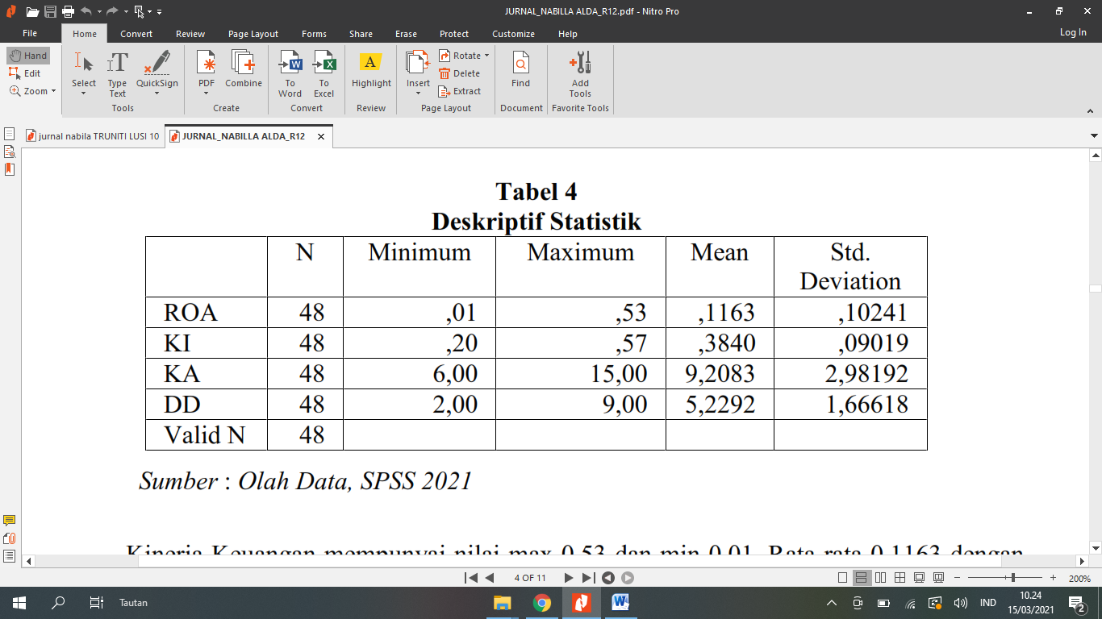

Source: SPSS Data Processing, 2021

The financial performance analysis indicates a range of values ranging from a minimum of 0.01 to a maximum of 0.53. The average value is 0.1163, with a standard deviation of 0.10241. This suggests that there is a level of fluctuation in the financial performance measures among the organisations that were analysed. Independent commissioners display a spectrum of values, ranging from a maximum of 0.57 to a minimum of 0.20. The mean score for independent commissioners was 0.3840, with a standard deviation of 0.09019. The numbers illustrate differences in the makeup and efficacy of autonomous commissioners among the companies included in the study.  
Within the domain of audit committees, the examination uncovers a spectrum of values ranging from 6.00 to 15.00, with an average score of 9.2083 and a standard deviation of 2.98192. This underscores the discrepancies in the composition and operation of audit committees within the organisations being examined. The board of directors exhibits a range of values, varying from 2.00 to 9.00. The mean score for the board of directors is 5.2292, with a standard deviation of 1.66618. The findings highlight variations in the structure and management methods of boards of directors within the corporations that were examined.

The research indicates that there is significant variability in the data related to the three independent variables: independent commissioners, audit committees, and the board of directors. The variety observed suggests variations in the corporate governance structures and practices among the enterprises included in the sample. The existence of such differences might potentially affect the efficacy of corporate governance processes and, as a result, have an impact on financial performance outcomes. These findings enhance our understanding of how corporate governance influences financial performance and emphasise the significance of strong governance frameworks in promoting organisational success. Kinerja

**Classic Assumption Test: Data Normality Test**

To confirm the accuracy of the statistical analysis carried out in this research, a test for data normality was completed. This test is crucial as it assesses whether the data conforms to a normal distribution, which is a fundamental assumption that underlies many statistical approaches. The test results yield vital insights into the distributional properties of the dataset, guiding further analytical judgements.

The data normality test yielded significant insights into the distribution of the variables being analysed. The test intended to determine if the data exhibited a symmetrical bell-shaped curve, which is a hallmark of a normal distribution, by evaluating the skewness and kurtosis of the data.

The results of the data normality test provide useful information into the characteristics of the dataset. An in-depth analysis of the skewness and kurtosis values offers insight into the extent to which the data diverges from a normal distribution.   
These findings are crucial in determining the choice of suitable statistical methods and appropriately interpreting the results. If the data closely follows a normal distribution, it may be suitable to use parametric statistical tests. Nevertheless, in the event of notable deviations from the normal distribution, it may be necessary to consider non-parametric alternatives or data manipulations to ensure the analysis remains robust.

The data normality test is an essential phase in the analytical process, allowing researchers to make informed decisions about the appropriateness of statistical approaches and ensuring the accuracy and consistency of the study results.

Table 3

Data Normality Test Results

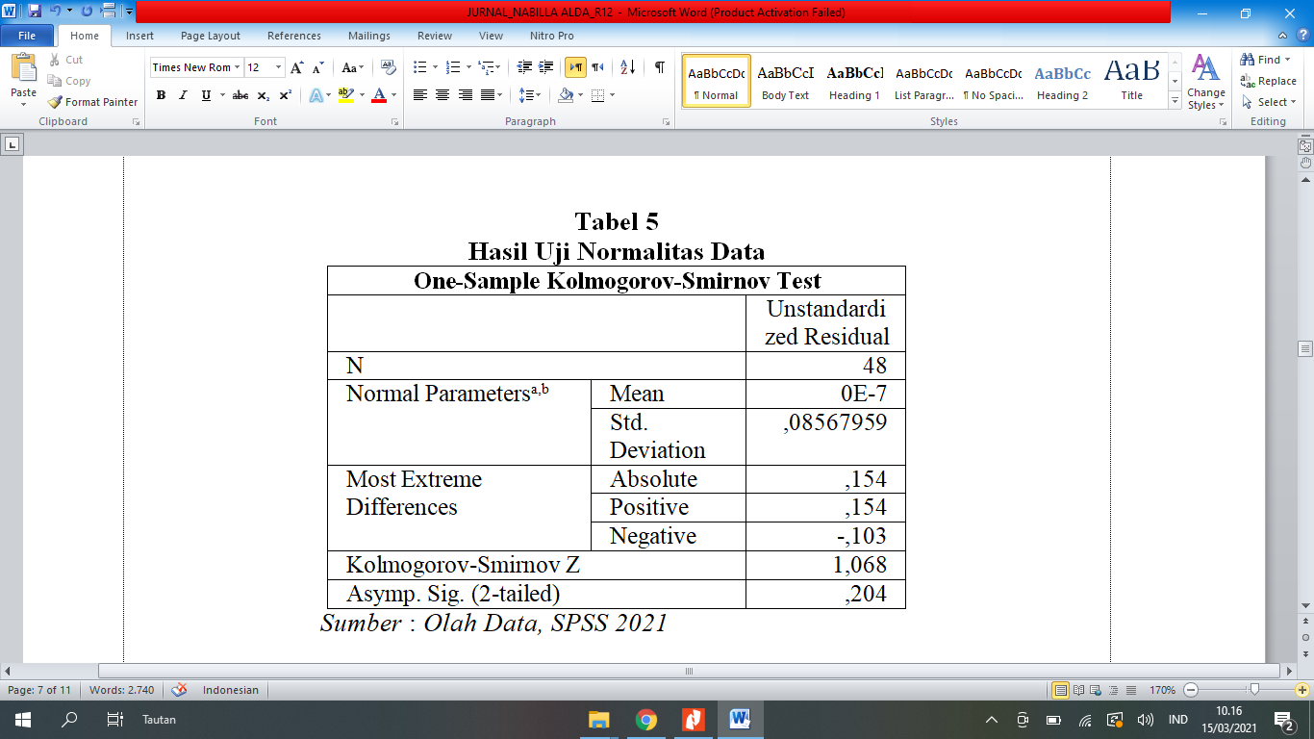

Source: SPSS Data Processing, 2021

The normality test, performed using the Kolmogorov-Smirnov test, provided valuable insights into the distribution of the dependent variable. The test yielded a K-Z value of 1.068, along with a significant value of 0.204. The significance value above the customary threshold of 0.05, indicating that the sample follows a normal distribution. This result indicates that the data points of the dependent variable are evenly spread around the average, reflecting the typical bell-shaped curve of a normal distribution. Therefore, this discovery confirms the hypothesis that the dependent variable follows a normal distribution within the dataset that was sampled. Confirming normality is crucial as it guarantees the suitability of parametric statistical methods for further analysis, thereby improving the reliability and validity of the study results.

**Multicollinearity Test**

The multicollinearity test serves as a crucial tool in assessing the presence of multicollinearity within a regression model, shedding light on the interrelationships between independent variables. Multicollinearity, by definition, signifies the existence of high correlations among independent variables in the regression framework. This phenomenon can potentially distort the results of regression analysis, undermining the accuracy and reliability of parameter estimates. Hence, the outcomes of the multicollinearity test provide invaluable insights into the extent to which such interdependencies may be influencing the model's performance. By identifying and addressing multicollinearity, researchers can refine their models, enhancing their predictive power and ensuring the validity of statistical inferences drawn from the analysis. Thus, the multicollinearity test serves as a vital diagnostic tool, enabling researchers to make informed decisions regarding the refinement and improvement of regression models.

Table 4

**Multicollinearity Test Result**

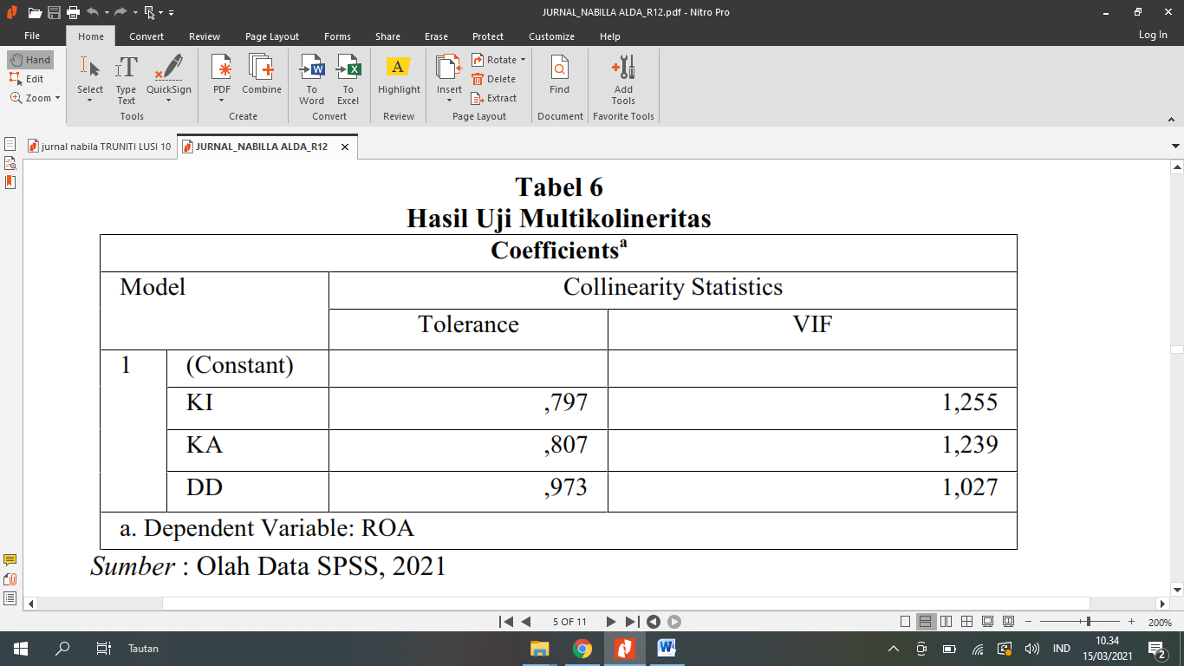

Source: SPSS Data Processing, 2021

The results of the multicollinearity test provide valuable insights into the relationships between the independent variables in the regression model. Upon examination, it was found that for the variable KI, the tolerance figure was recorded at 0.797, falling below the recommended threshold of 0.1, while the variance inflation factor (VIF) figure was 1.255, exceeding the threshold of 10. Similarly, for the variable KA, the tolerance figure was 0.807, below 0.1, and the VIF figure was 1.239, surpassing 10. Additionally, for the variable DD, the tolerance figure was 0.973, below 0.1, and the VIF figure was 1.027, exceeding 10.

However, it's important to note that these results do not indicate the presence of multicollinearity in the regression model. In fact, the tolerance values being greater than 0.1 and the VIF values being smaller than 10 signify that multicollinearity is not a concern among the independent variables. This suggests that the independent variables included in the regression model are not excessively correlated with each other, thus meeting the assumption of independence necessary for reliable regression analysis.

**Autocorrelation Test**

The autocorrelation test serves as a critical diagnostic tool in regression analysis, providing insights into the presence of autocorrelation within the linear regression model under investigation. Autocorrelation, also known as serial correlation, occurs when the residuals or error terms of a regression model exhibit patterns of correlation with themselves over time or across observations. This phenomenon can compromise the validity of regression results, leading to biased parameter estimates and inflated standard errors. By conducting an autocorrelation test, researchers can ascertain whether the assumptions of independence among the error terms are violated, thereby ensuring the reliability and robustness of the regression analysis findings. Therefore, the autocorrelation test plays a pivotal role in identifying and mitigating potential issues related to autocorrelation, enabling researchers to make informed decisions regarding the appropriate specification and interpretation of regression models.

**Table 5**

**Autocorrelation Result**

|  |  |
| --- | --- |
| Model | DW |
| 1 | 1,556 |

Source: SPSS Data Processing, 2021

The culmination of the autocorrelation test yields a final result expressed as dL < dW < 4-dU or, in numerical terms, 1.4500 < 1.556 < 2.3769. This outcome offers critical insights into the presence or absence of autocorrelation within the linear regression model employed by the researcher. In interpreting these results, it's important to note that a positive value signifies support for the research hypothesis, indicating the absence of symptoms of autocorrelation in the regression model. Essentially, this outcome suggests that the residuals or error terms in the regression analysis do not exhibit patterns of correlation over time or across observations. Consequently, the absence of autocorrelation reinforces the validity and reliability of the regression analysis findings, affirming the integrity of the statistical inference drawn from the model. Overall, the results of this test provide assurance regarding the robustness of the regression analysis methodology employed in the study, enhancing confidence in the accuracy and validity of the research outcomes.

**Heteroscedasticity Test**

In order to detect heteroscedasticity within the study, the researcher employed the Scatterplots test, a commonly utilized method for assessing the presence of non-constant variance in regression residuals. This test involves visually examining scatterplots, which depict the relationship between the residuals (vertical axis) and the predicted values (horizontal axis) generated by the regression model. By scrutinizing the patterns and dispersion of data points within these scatterplots, researchers can discern any systematic deviations from uniformity in the variance of the residuals across different levels of the predicted values. In essence, the Scatterplots test serves as a diagnostic tool to identify whether the variance of the residuals exhibits any discernible patterns or trends, thereby indicating the presence of heteroscedasticity. The results of this test provide critical insights into the robustness and reliability of the regression analysis findings, informing subsequent steps in model refinement and interpretation. Therefore, by leveraging the Scatterplots test, the researcher endeavors to gain a comprehensive understanding of the presence and implications of heteroscedasticity within the study dataset.

Figure 1

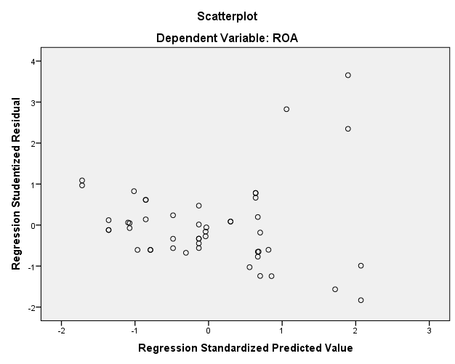

*Source: SPSS Data Processing, 2021*

The scatter plot depicted in the image above reveals a lack of discernible patterned shapes and displays points that are evenly distributed across the range of Y-axis values. This observation suggests that there is no systematic relationship between the independent and dependent variables, indicating the absence of heteroscedasticity. Heteroscedasticity occurs when the variability of the error terms in a regression model is not consistent across different levels of the independent variable, leading to non-uniform dispersion of data points around the regression line. However, in this instance, the absence of any noticeable clustering or widening of data points as they extend along the Y-axis implies a consistent level of variability in the error terms across the range of observed values. Therefore, based on the visual assessment of the scatter plot, it can be concluded that there is no evidence of heteroscedasticity in the relationship between the variables under consideration. This finding enhances the credibility of the regression analysis results and lends confidence to the validity of the statistical inferences drawn from the model.

**Multiple Linear Regression Analysis**

The multiple linear regression analysis serves as a crucial statistical tool for examining the relationship between a dependent variable and multiple independent variables. This analysis aims to quantify the extent to which the independent variables influence the dependent variable, providing valuable insights into the underlying dynamics of the dataset. In the context of this study, the multiple linear regression analysis was conducted using SPSS, a widely used statistical software package known for its robust analytical capabilities. By employing SPSS, the researcher was able to perform a comprehensive examination of the dataset and derive meaningful conclusions regarding the magnitude and direction of the effects of the independent variables on the dependent variable. Through this analysis, the researcher gains a deeper understanding of the factors driving variations in the dependent variable, thereby facilitating informed decision-making processes and enhancing the overall interpretability of the study findings.

Table 6

**Multiple Linear Regression Analysis**

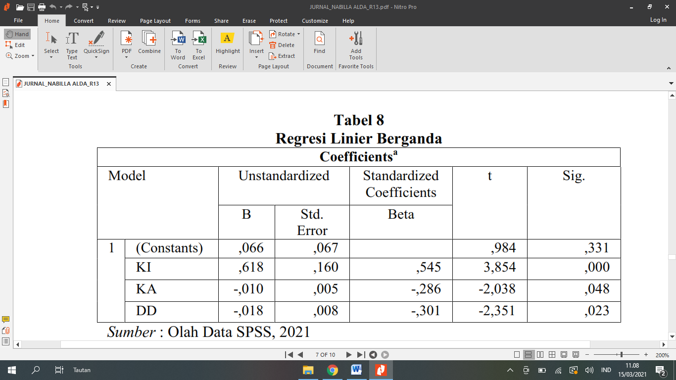

Source: SPSS Data Processing, 2021

The results of multiple linear regression analysis can be summarized by the regression equation, which is expressed as follows:

Y = $a$ + $b_{1}x_{1}$ + $b_{2}x_{2}$ + $b_{3}x_{3}$ + $e$

In this equation, (Y) represents the dependent variable, while (x_1, x_2) and (x_3) denote the independent variables. The coefficients (b_1, b_2) and (b_3) represent the slopes or regression coefficients associated with each independent variable, indicating the magnitude and direction of their respective effects on the dependent variable. The constant term (a) represents the intercept, indicating the value of the dependent variable when all independent variables are equal to zero. The error term (e) represents the residual or unexplained variation in the dependent variable that is not accounted for by the independent variables in the model.

Upon conducting multiple linear regression analysis, the specific regression equation derived for the dataset is as follows:

Y = $0,066$ + $0,618x_{1}$ $- 0,010x_{2}$ $-$ $0,018x_{3}$ + $e$

In this equation, the constant term (a) is determined to be 0.066, indicating the baseline value of the dependent variable. The coefficients (b_1, b_2) and (b_3) are calculated as 0.618, -0.010, and -0.018, respectively, revealing the respective contributions of the independent variables (x_1, x_2) and (x_3) to the overall variation in the dependent variable (Y). The presence of the error term (e) acknowledges that there may be unobserved factors or random variation influencing the dependent variable that are not captured by the independent variables included in the regression model. Overall, the multiple linear regression equation provides a comprehensive framework for understanding the relationship between the dependent and independent variables in the dataset and facilitates interpretation of the results of the regression analysis.

**R2 Determination Coefficient Test**

The hypothesis test concerning the coefficient of determination, often denoted as (R2), plays a fundamental role in evaluating the efficacy of the regression model in explaining variations observed in the independent variables. This test serves as a critical measure of the model's goodness of fit, providing insights into the extent to which the independent variables collectively account for the variability observed in the dependent variable. Through the coefficient of determination test, researchers can assess the proportion of variance in the dependent variable that is explained by the independent variables included in the regression model. This information is invaluable as it allows for an informed evaluation of the model's predictive power and overall effectiveness in capturing the underlying relationships between variables. Consequently, the results obtained from the coefficient of determination test furnish researchers with essential guidance on the appropriateness and reliability of the regression model in addressing the research objectives and hypotheses. Thus, the coefficient of determination test represents a crucial step in the analytical process, offering valuable insights into the explanatory capacity of the regression model and facilitating informed interpretations of research findings.

Table 7

R Square Test Results

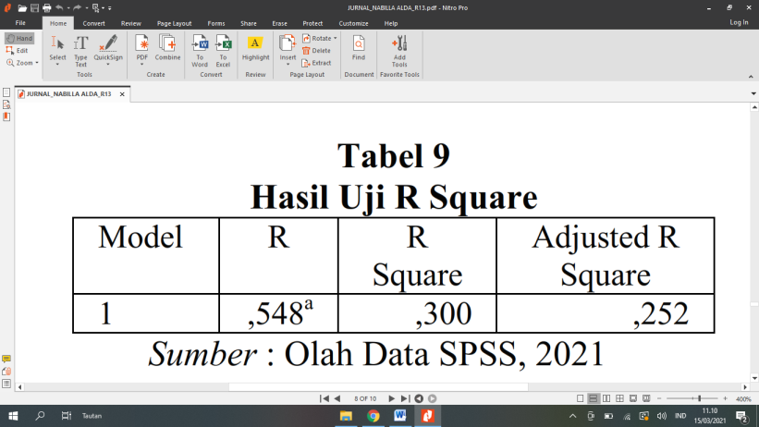

Source: SPSS Data Processing, 2021

The Adjusted R-squared value obtained for the independent commissioner, audit committee, and board of directors variables is 0.252, which translates to 25.2% explanatory power. This finding suggests that the independent variables included in the regression model utilized in this research collectively account for 25.2% of the variability observed in the dependent variable. In other words, these governance-related factors offer partial insight into the variations observed in the dependent variable. However, it is essential to acknowledge that the remaining 74.8% of the variation in the dependent variable is unexplained by the independent variables considered in this model. This implies the presence of other factors or variables not included in the regression analysis that may contribute to the observed variations in the dependent variable. Consequently, while the independent variables investigated in this research provide valuable insights, a significant portion of the variability in the dependent variable remains attributable to other unidentified factors. This underscores the complexity of the phenomenon under study and highlights the need for further research to explore additional variables that may influence the outcome of interest comprehensively.

**T-Test**

The hypothesis test, specifically the t-test, serves as a pivotal tool for assessing the influence of variable X on variable Y within the research context. Its utility lies in determining the significance of the relationship between the independent and dependent variables, shedding light on whether variable X exerts a meaningful impact on variable Y and elucidating the directionality of this influence, whether positive or negative. Through the t-test, the researcher gains valuable insights into the strength and nature of the association between the variables under scrutiny, enabling informed decision-making regarding the acceptance or rejection of research hypotheses. The results obtained from the t-test are instrumental in providing empirical evidence to support or refute the hypothesized relationships between variables, thereby advancing the understanding of the underlying dynamics and contributing to the broader body of knowledge in the field. Therefore, the t-test represents a critical analytical tool in hypothesis testing, facilitating rigorous examination of causal relationships and enhancing the rigor and validity of research findings.

Table 8

T Test Result

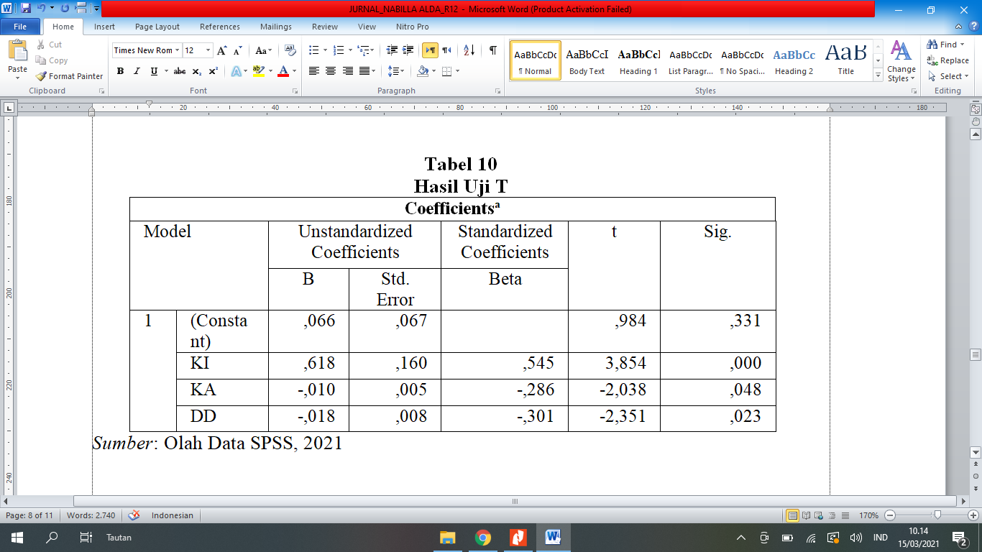

Source: SPSS Data Processing, 2021

The results of the t-tests conducted in this study provide compelling evidence regarding the influence of various governance components on financial performance variables. Firstly, the t-test concerning independent commissioners yielded a significant figure of 0.000, which is below the conventional threshold of 0.05. This outcome suggests a statistically significant influence of independent commissioners on financial performance variables. It indicates that the presence and actions of independent commissioners within corporate governance structures exert a discernible impact on the financial performance outcomes of the sampled companies.

Similarly, the t-test pertaining to the audit committee revealed a significant figure of 0.048, also falling below the 0.05 threshold. This finding underscores the influence of the audit committee on financial performance variables within the sampled companies. It implies that the activities and oversight functions carried out by the audit committee contribute significantly to shaping financial performance outcomes, highlighting the importance of effective audit committee structures and practices in fostering organizational success.

Furthermore, the t-test concerning the board of directors yielded a significant figure of 0.023, indicating a statistically significant influence on financial performance variables. This result suggests that the composition, actions, and decision-making processes of the board of directors play a pivotal role in determining the financial performance outcomes of the companies under investigation. It underscores the critical importance of robust governance mechanisms at the board level in driving positive financial outcomes and enhancing shareholder value.

The results of the t-tests provide empirical support for the significant influence of independent commissioners, audit committees, and boards of directors on financial performance variables within the sampled companies. These findings underscore the vital role of effective corporate governance structures and practices in driving organizational success and underscore the need for continued attention to governance mechanisms in corporate decision-making processes.

**Discussion**

The dynamics of corporate governance, as elucidated by agency theory, underscore the relationship between principals and agents within organizational frameworks. Principals, typically shareholders, delegate authority to agents, commonly represented by the board of directors, to oversee company operations (Choi et al., 2021; Ejoh et al., 2019; Walls et al., 2012). Agency theory aims to address inherent conflicts of interest between these parties, necessitating supervisory mechanisms such as independent commissioners and audit committees (Choi et al., 2021; Shailer, 2018; Singh & Davidson III, 2003). These oversight entities are tasked with supervising firm management to ensure compliance with company policies and mitigate agency costs, which encompass the financial burdens associated with monitoring agent behavior to align with principal objectives (Abbot et al., 2016; Al-Hadrami et al., 2020; Aulakh & Gencturk, 2000; Coles et al., 2001).

In assessing a company's financial performance, robust corporate governance practices are essential for gauging its ability to generate profits efficiently. Financial performance analysis, rooted in strong governance principles, offers insights into a company's financial health. Independent commissioners serve as vital internal controls, overseeing top management policies (Abbott & Parker, 2000; Kueppers & Sullivan, 2010; Steinberg & Faulk, 1991). Top management, typically represented by the board of directors, consists of controlling shareholders or appointed individuals responsible for guiding the company's trajectory. To bolster commissioners' oversight of operational activities, the establishment of audit committees enhances their ability to monitor and fulfill supervisory obligations (Brennan & Solomon, 2008; Hooghiemstra & Van Manen, 2004).

The intricate interplay among independent commissioners, audit committees, and the board of directors underscores the complexity of corporate governance mechanisms. Independent commissioners safeguard shareholder interests, ensuring managerial accountability and alignment with company objectives (Klein, 2002; Turley & Zaman, 2004; Zhang et al., 2007). Their role is reinforced by audit committees, which provide additional oversight, particularly in scrutinizing financial reporting methods and internal control systems. The board of directors, as the highest governing authority, bears ultimate responsibility for charting the company's strategic course while upholding transparency, accountability, and integrity (Baker & Owsen, 2002; Baxter, 2010; Deli & Gillan, 2000).

The symbiotic relationship among these governance components underscores their collective role in enhancing corporate transparency, mitigating agency risks, and bolstering overall financial performance. Thus, a comprehensive examination of their interconnectedness is essential to grasp their impact on organizational outcomes and devise effective strategies for fortifying corporate governance systems to foster sustained value creation (Bebchuk & Weisbach, 2010; Bushman et al., 2004; Walls et al., 2012).

**Conclusion**

Several noteworthy conclusions have been formed based on the framing of the research challenge and the outcomes of hypothesis testing. Initially, it was discovered that the inclusion of autonomous commissioners has a favourable effect on financial performance. In contrast, the analysis demonstrated that the existence of audit committees has a detrimental impact on financial performance, as does the variable related to the board of directors. Furthermore, it has been determined that the combined influence of independent commissioners, audit committees, and board of directors impacts financial performance.

Based on these findings, it is advisable for future research projects to broaden their sample size beyond companies exclusively in the food and beverage industry. Instead, they should consider including a wider variety of industrial sectors represented by firms listed on the Indonesia Stock Exchange. Furthermore, it is recommended to include other variables, as the variables under investigation - independent commissioners, audit committees, and board of directors - were only able to explain 25.2% of the variation in financial performance. Researchers can enhance their understanding of the diverse factors of financial performance by incorporating variables such as managerial ownership and others.

To tackle the variables that had a negative impact, it is crucial to focus on the makeup of the board of directors and the structure of the audit committee in organisations. An in-depth analysis of these components may reveal ways to improve the level of financial performance. Companies might potentially improve their financial performance outcomes by carefully examining the size and composition of their board of directors, as well as the effectiveness of their audit committee operations, in order to counteract the negative effects highlighted in this research.

**References**

Abbasi, K., Alam, A., & Bhuiyan, Md. B. U. (2020). Audit committees, female directors and the types of female and male financial experts: Further evidence. *Journal of Business Research*, *114*, 186–197. https://doi.org/https://doi.org/10.1016/j.jbusres.2020.04.013

Abbot, L. J., Daugherty, B., Parker, S., & Peters, G. F. (2016). Internal Audit Quality and Financial Reporting Quality: The Joint Importance of Independence and Competence. *Journal of Accounting Research*, *54*(1), 3–40. https://doi.org/https://doi.org/10.1111/1475-679X.12099

Abbott, L. J., & Parker, S. (2000). Auditor Selection and Audit Committee Characteristics. *AUDITING: A Journal of Practice & Theory*, *19*(2), 47–66. https://doi.org/10.2308/aud.2000.19.2.47

Aebi, V., Sabato, G., & Schmid, M. (2012). Risk management, corporate governance, and bank performance in the financial crisis. *Journal of Banking & Finance*, *36*(12), 3213–3226. https://doi.org/https://doi.org/10.1016/j.jbankfin.2011.10.020

Al-Hadrami, A., Rafiki, A., & Sarea, A. (2020). The impact of an audit committee’s independence and competence on investment decision: a study in Bahrain. *Asian Journal of Accounting Research*, *5*(2), 299–313. https://doi.org/10.1108/AJAR-02-2020-0008

Aulakh, P. S., & Gencturk, E. F. (2000). International Principal–Agent Relationships: Control, Governance and Performance. *Industrial Marketing Management*, *29*(6), 521–538. https://doi.org/https://doi.org/10.1016/S0019-8501(00)00126-7

Baxter, P. (2010). Factors associated with the quality of audit committees. *Pacific Accounting Review*, *22*(1), 57–74. https://doi.org/10.1108/01140581011034227

Bebchuk, L. A., & Weisbach, M. S. (2010). The State of Corporate Governance Research. *The Review of Financial Studies*, *23*(3), 939–961. https://doi.org/10.1093/rfs/hhp121

Bhujel, S. (2020). Role of Financial Statement in Investment Decision Making Process. *Journal of Balkumari College*, *9*(1), 105–108. https://doi.org/https://doi.org/10.3126/jbkc.v9i1.30094

Brennan, N. M., & Solomon, J. (2008). Corporate governance, accountability and mechanisms of accountability: an overview. *Accounting, Auditing & Accountability Journal*, *21*(7), 885–906. https://doi.org/10.1108/09513570810907401

Brown, L. D., & Caylor, M. L. (2009). Corporate governance and firm operating performance. *Review of Quantitative Finance and Accounting*, *32*(2), 129–144. https://doi.org/10.1007/s11156-007-0082-3

Bushman, R., Chen, Q., Engel, E., & Smith, A. (2004). Financial accounting information, organizational complexity and corporate governance systems. *Journal of Accounting and Economics*, *37*(2), 167–201. https://doi.org/https://doi.org/10.1016/j.jacceco.2003.09.005

Choi, D. W., Velikova, N., & Lee, S. (2021). Influence of Corporate Governance on Financial Performance among Alcohol Beverage Firms. *Journal of Quality Assurance in Hospitality & Tourism*, *22*(4), 425–446. https://doi.org/10.1080/1528008X.2020.1802389

Chu, L., Mathieu, R., & Mbagwu, C. (2019). Independent Directors, Business Risk, and the Informativeness of Accounting Earnings for Debt Contracting. *Canadian Journal of Administrative Sciences / Revue Canadienne Des Sciences de l’Administration*, *36*(4), 559–575. https://doi.org/https://doi.org/10.1002/cjas.1521

Coles, J. W., McWilliams, V. B., & Sen, N. (2001). An examination of the relationship of governance mechanisms to performance. *Journal of Management*, *27*(1), 23–50. https://doi.org/10.1177/014920630102700102

Deli, D. N., & Gillan, S. L. (2000). On the demand for independent and active audit committees. *Journal of Corporate Finance*, *6*(4), 427–445. https://doi.org/https://doi.org/10.1016/S0929-1199(00)00016-X

Ejoh, N. O., Oko, S. U., & Okpa, F. A. (2019). Corporate Governance and Leverage Implications on Firms’ Profitability, Cash Flows and Value in Nigeria. *Research Journal of Finance and Accounting*, *10*(24), 29–40. https://doi.org/10.7176/rjfa/10-24-04

Frias-Aceituno, J. V, Rodríguez-Ariza, L., & Garcia-Sánchez, I. M. (2014). Explanatory Factors of Integrated Sustainability and Financial Reporting. *Business Strategy and the Environment*, *23*(1), 56–72. https://doi.org/https://doi.org/10.1002/bse.1765

Hooghiemstra, R., & Van Manen, J. (2004). The Independence Paradox: (im)possibilities facing non-executive directors in The Netherlands. *Corporate Governance: An International Review*, *12*(3), 314–324. https://doi.org/https://doi.org/10.1111/j.1467-8683.2004.00372.x

Ika, S. R., Nugroho, J. P., Achmad, N., & Widagdo, A. K. (2021). The impact of corporate governance on environmental reporting: Evidence from the Indonesian manufacturing industry. *IOP Conference Series: Earth and Environmental Science*, *739*(1). https://doi.org/10.1088/1755-1315/739/1/012030

Ives, M. (2015). Financial Statement Analysis. In D. A. Bearfield, E. Berman, & M. J. Dubnick (Eds.), *Encyclopedia of Public Administration and Public Policy-5 Volume Set* (3rd ed.). Routledge. https://doi.org/https://doi.org/10.1081/E-EPAP3

Karim, A., & Purwanto, A. (2020). The relationship between good corporate governance and performance of most liquid stocks in Indonesia. *Research in World Economy*, *11*(1), 137–142. https://doi.org/10.5430/rwe.v11n1p137

Klein, A. (2002). Audit committee, board of director characteristics, and earnings management. *Journal of Accounting and Economics*, *33*(3), 375–400. https://doi.org/https://doi.org/10.1016/S0165-4101(02)00059-9

Kopecká, N. (2018). A Literature Review of Financial Performance Measures and Value Relevance. In D. Procházka (Ed.), *The Impact of Globalization on International Finance and Accounting* (pp. 385–393). Springer International Publishing.

Krishnamoorthy, G., Wright, A., & Cohen, J. (2002). Audit Committee Effectiveness and Financial Reporting Quality: Implications for Auditor Independence. *Australian Accounting Review*, *12*(28), 3–13. https://doi.org/https://doi.org/10.1111/j.1835-2561.2003.tb00206.x

Kueppers, R. J., & Sullivan, K. B. (2010). How and why an independent audit matters. *International Journal of Disclosure and Governance*, *7*(4), 286–293. https://doi.org/10.1057/jdg.2010.22

Lin, J. W., & Hwang, M. I. (2010). Audit Quality, Corporate Governance, and Earnings Management: A Meta-Analysis. *International Journal of Auditing*, *14*(1), 57–77. https://doi.org/https://doi.org/10.1111/j.1099-1123.2009.00403.x

Liu, C.-Y., Lee, C.-Y., & Tsai, H.-J. S. (2018). Corporate governance and food firms’ unethical production practices? *British Food Journal*, *120*(10), 2222–2235. https://doi.org/10.1108/BFJ-03-2018-0133

Mao, Z., & Gu, Z. (2008). The Relationship Between Financial Factors and Firm Performance: Empirical Evidence from U.S. Restaurant Firms. *Journal of Foodservice Business Research*, *11*(2), 138–159. https://doi.org/10.1080/15378020801995564

Reddy, K., Locke, S., & Scrimgeour, F. (2010). The efficacy of principle‐based corporate governance practices and firm financial performance. *International Journal of Managerial Finance*, *6*(3), 190–219. https://doi.org/10.1108/17439131011056224

Renders, A., Gaeremynck, A., & Sercu, P. (2010). Corporate-Governance Ratings and Company Performance: A Cross-European Study. *Corporate Governance: An International Review*, *18*(2), 87–106. https://doi.org/https://doi.org/10.1111/j.1467-8683.2010.00791.x

Baker, C. R., & Owsen, D. M. (2002). Increasing the role of auditing in corporate governance. *Critical Perspectives on Accounting*, *13*(5), 783–795. https://doi.org/https://doi.org/10.1006/cpac.2002.0566

Saha, N. K., Moutushi, R. H., & Salauddin, M. (2018). Corporate Governance and Firm Performance: The Role of the Board and Audit Committee. *Asian Journal of Finance & Accounting*, *10*(1), 210. https://doi.org/10.5296/ajfa.v10i1.12933

Shahwan, Y. (2008). Qualitative characteristics of financial reporting: a historical perspective. *Journal of Applied Accounting Research*, *9*(3), 192–202. https://doi.org/10.1108/09675420810919748

Shailer, G. (2018). Agency Theory. In D. C. Poff & A. C. Michalos (Eds.), *Encyclopedia of Business and Professional Ethics* (pp. 1–4). Springer International Publishing. https://doi.org/10.1007/978-3-319-23514-1_151-1

Singh, M., & Davidson III, W. N. (2003). Agency costs, ownership structure and corporate governance mechanisms. *Journal of Banking & Finance*, *27*(5), 793–816. https://doi.org/https://doi.org/10.1016/S0378-4266(01)00260-6

Steinberg, R. M., & Faulk, R. J. (1991). Internal control—a question of integrity, ethics, and competence. *Journal of Corporate Accounting & Finance*, *2*(4), 395–409. https://doi.org/https://doi.org/10.1002/jcaf.3970020402

Sun, J., Liu, G., & Lan, G. (2011). Does Female Directorship on Independent Audit Committees Constrain Earnings Management? *Journal of Business Ethics*, *99*(3), 369–382. https://doi.org/10.1007/s10551-010-0657-0

Thomas, A. (2003). Why corporate reporting is a strategic opportunity. *Journal of Corporate Accounting & Finance*, *15*(1), 63–68. https://doi.org/https://doi.org/10.1002/jcaf.10219

Turley, S., & Zaman, M. (2004). The Corporate Governance Effects of Audit Committees. *Journal of Management and Governance*, *8*(3), 305–332. https://doi.org/10.1007/s10997-004-1110-5

Uzma, S. H. (2018). Corporate governance practices: global convergence and Indian perspective. *Qualitative Research in Financial Markets*, *10*(3), 285–308. https://doi.org/10.1108/QRFM-12-2016-0049

Walls, J. L., Berrone, P., & Phan, P. H. (2012). Corporate governance and environmental performance: is there really a link? *Strategic Management Journal*, *33*(8), 885–913. https://doi.org/https://doi.org/10.1002/smj.1952

Zhang, Y., Zhou, J., & Zhou, N. (2007). Audit committee quality, auditor independence, and internal control weaknesses. *Journal of Accounting and Public Policy*, *26*(3), 300–327. https://doi.org/https://doi.org/10.1016/j.jaccpubpol.2007.03.001